John Ye

[Company name]  [Company address]

**Evaluate and Communicate Business Requirements IRNANDI MULIAWAN 18073**

|  |  |  |  |
| --- | --- | --- | --- |
| Name of Student | IRNANDI MULIAWAN | ID | 18073 |

**Assessment – Research and Questioning**

Contents

Instructions: 1

Business Scenario 1

Task 1: Determine support areas 2

Task 2: Identify stakeholders 2

Task 3: Develop support procedures 2

Task 4: Assign Support Personnel 2

Task 5: Short Answer Questions 3

Task 6: Multiple Choice Questions 3

Search Index 8

# Instructions:

This is an individual assessment. Answer all the questions on the document provided by your Trainer.

***Duration:***

Trainer will set the duration of the assessment.

Please Review My Project website and form survey

View My Web support :

<https://nandilagi.github.io/ecbr18073NandiT32022/>

View my form survey

<https://forms.gle/7zrzEPAQo6VdPiVg9>

View my form result

<https://docs.google.com/spreadsheets/d/1ddmGuxHJTGF8FCZALD2bMW0Bvia2aY1IASE_1qaXKG8/edit?usp=sharing>

# Business Scenario

D&K Books Pty Ltd is a bookstore owned by Mr. Dean Kerr. The business occupies two levels of an office building connected by escalators and lifts. D&K Books employs approximately six sales staff, one operation manager, two administrative officers, a bookkeeper and a marketing manager. They have an Ethernet network consisting of ten PCs (Intel I3 Desktop cloned), two switches, a router and three printers. They use the QuickBooks software to manage their entire business, including sales, inventory, ordering, accounts receivable, accounts payable, payroll and employee management. They also have two EFTPOS terminals one on each floor.

D&K Books has a Linux server that stores all of the data including the QuickBooks database. The server is backed up to tape regularly. They also have a website (hosted on an Australian ISP’s server, dynamic and static pages using asp.net) on which customers can browse the product catalogue and view current specials. They also lease a telephone system from Live Telecoms. The PABX (phone system) consists of a main switchboard and five remote phones with three incoming lines and a message-on-hold queue system.

# Task 1: Determine support areas

Identify information technology (HW and SW) and list the technology in use in D&K Books and consider the following:

* What sort of support does the technology require?
* Who is likely to provide this support?
* Does the support arrangement already exist?

Present your answer in a table such as the one below:

|  |  |  |  |  |
| --- | --- | --- | --- | --- |
| **Technology** | **Description** | **Support Required** | **Provider** | **Support Already exists? (Yes/No)** |
| QuickBooks Software | software that keeps track of all accounts, stock, GST, etc. | customisation, training, upgrades, bug fixes (patching), user support | [www.intuit.com.au](http://www.intuit.com.au)  online to find more | no |
| PC’s | Intel I3 Desktop cloned | upgrades, repairs, troubleshooting, maintenance, backup, customisation, network to link |  | No. Need find one person to do this job |
| Server | Linux Server with tape backup  May need upgrade to hard disk backup | User account management, security policy implementation, home folder management, permissions management, backup and restore, operating system patching, software installation |  | No |
| EFTPOS | Easy to use | No need | shop | Yes |
| Telephone system | Low cost | Phone company | Telstra | Yes |
| Website | Low cost | Yes | Godaddy | Yes |

Please review my website:

<https://nandilagi.github.io/ecbr18073NandiT32022/>

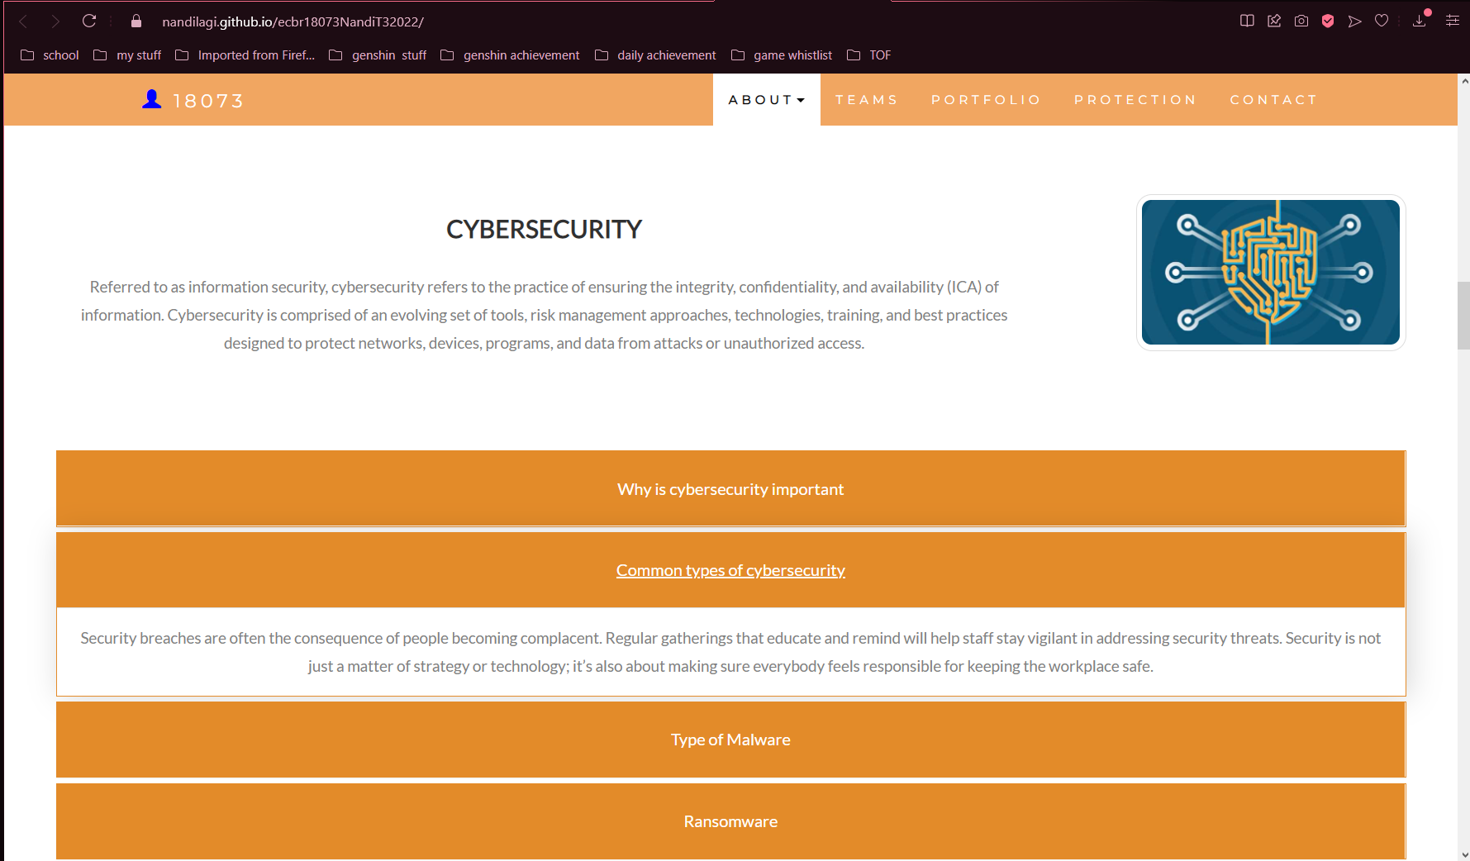

# Task 2: Identify stakeholders

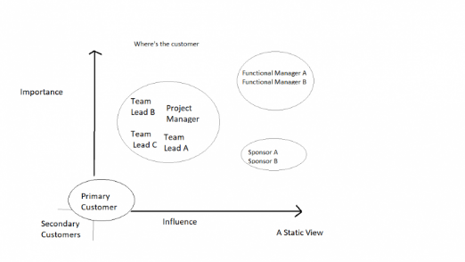Identify stakeholders related in D&K Books system

Stakeholders

Bookstore Admin:

Bookstore Admin gives a book and orders read/write access to all components of Bookstore, including settings. You'll need this role in order to set up Bookstore, together with Financial Admin to set up the Chart of Accounts.

Bookstore Customers:

Bookstore gives a user the ability to run day-to-day operations in Liberty Bookstore—processing orders (Online) and viewing reports. They do not have access to Bookstore Settings.

# Task 3: Develop support procedures

1. Describe one positive and one negative experience you have had when seeking assistance from a telecommunications company, an ISP or a computer supplier. Your experience may be via telephone, email or even voice recognition.

Answer :

|  |  |  |
| --- | --- | --- |
| Type | Positive | Negative |
| Telephone | Can do it from home | To long to get connected with the line or customer service |
| Email | Can send document, picture or any media | The customer service didn’t reply fast enough and the mail could be followed up with different person if the issue is not fixed |
| Go to company | Takes time to travel, have to book or making an appointment | Cost time and money on trip |

1. Using the experiences described above please answer the following questions.
   1. What support aspects were professional and/or unprofessional?
   2. How long did the support process take?
   3. Were the steps logical?
   4. Did they solve your problem?
   5. Was the call deflected to another area?

Answer

|  |  |
| --- | --- |
| Items | experiences |
| What support aspects | The professional things are they mostly know the problem, but the unprofessional things are it’s really taking a long time to get your phone picked up by the customer service, or you have to wait the phone line.  The technician also good and professional but we have to wait for a week just for fixing trouble for half and hour |
| How long | Slow in response for call, and the time technician came also long  We have to wait for 1 hour when calling the customer service, and the technician came after a week when we called the company |
| Steps logical | The steps are logical, both of the customer service and technician were doing good when explaining the problem |
| Solve | The problem solved immediately after the technician come |
| Another area | They could just fasten their communication with customer by adding more staff  and also, they could fix it faster if they had enough technician on field. |

Using feedback form or Google survey form.

Here is the very simple survey demo: <https://forms.gle/7zrzEPAQo6VdPiVg9>

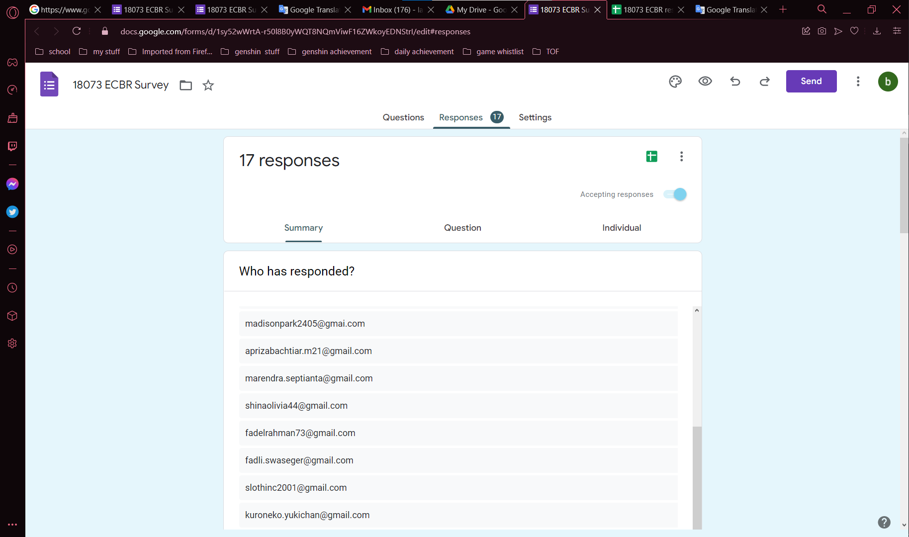

After I tested my friends, I could get nice response like:

<https://docs.google.com/spreadsheets/d/1ddmGuxHJTGF8FCZALD2bMW0Bvia2aY1IASE_1qaXKG8/edit?usp=sharing>

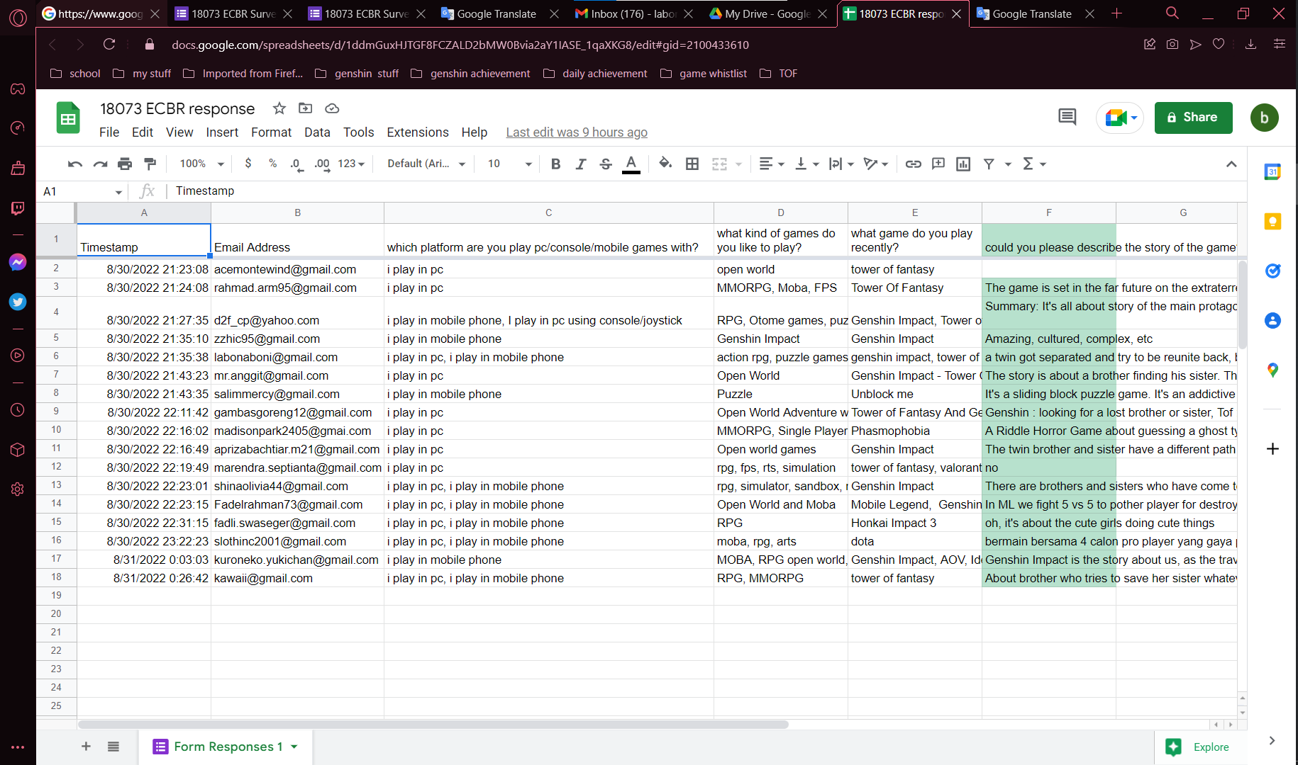

Please review my website: <https://nandilagi.github.io/ecbr18073NandiT32022/>

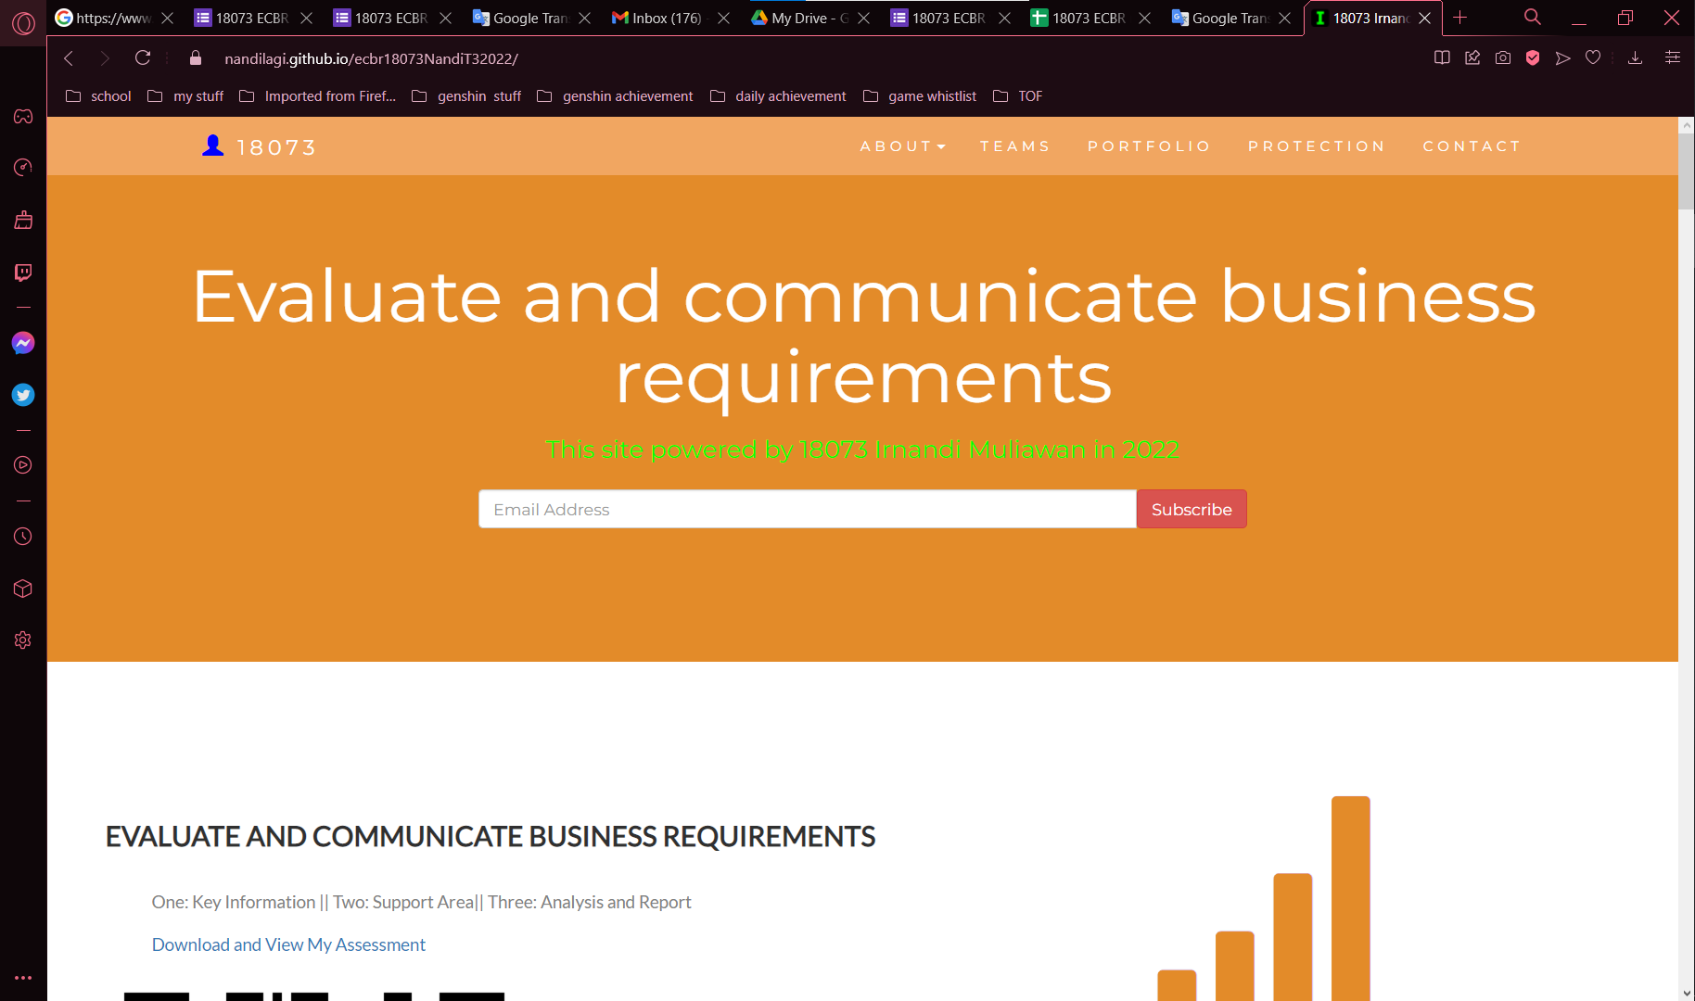

# Task 4: Assign Support Personnel

Classify the following into soft skills and technical skills. Your answer should take the form of a table shown below.

|  |  |  |
| --- | --- | --- |
| **Skill** | **Soft skill** | **Technical skill** |
| A knowledge of Linux |  | X |
| The ability to work under pressure | X |  |
| The administration of Windows 2008 Server |  | X |
| The ability to formulate network and IT policies | X |  |
| The ability to write network documentation | X |  |
| The ability to give presentations | X |  |

Please review my website as a supporting document :

<https://nandilagi.github.io/ecbr18073NandiT32022/>

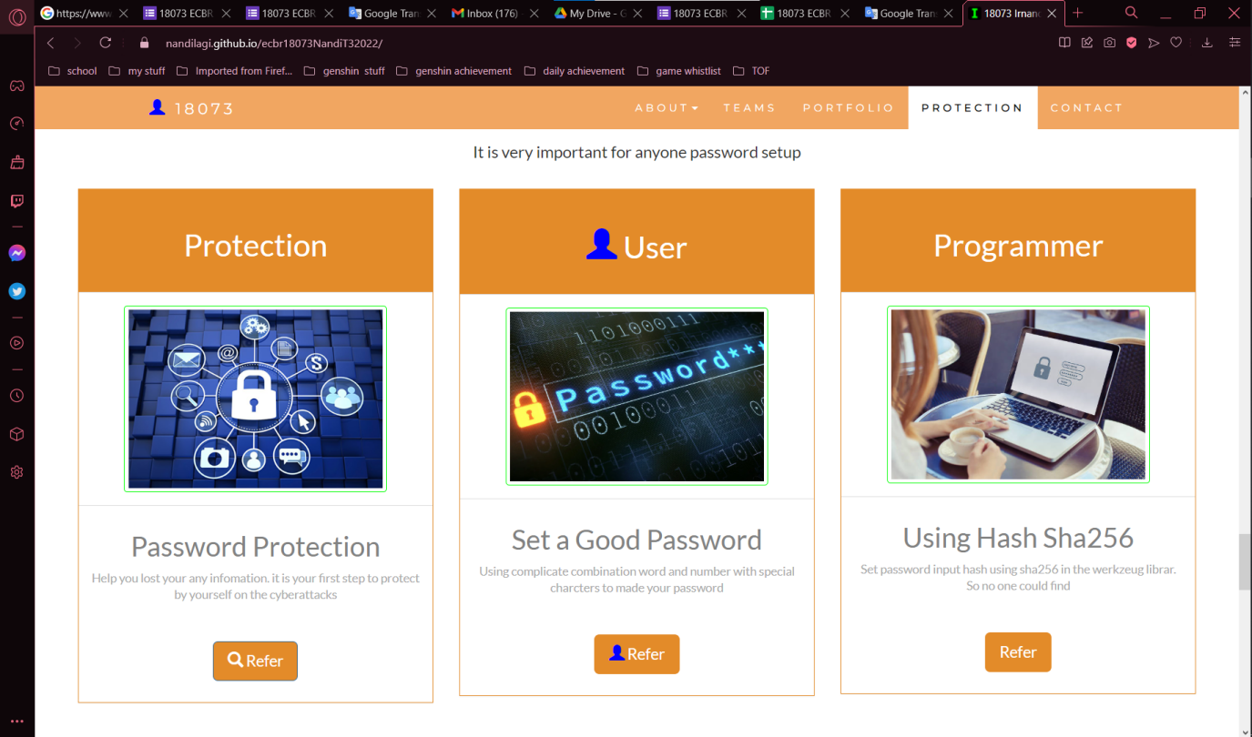

# Task 5: Short Answer Questions

1. **Explain the relationship between data, information and knowledge.**

Answer :

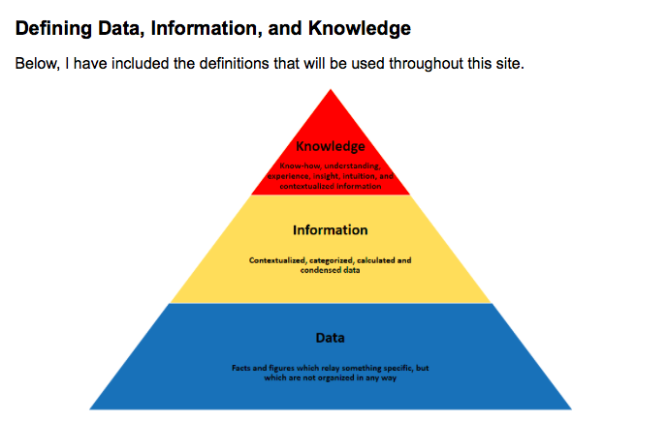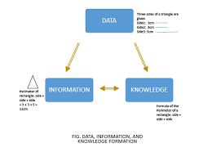

Data are the raw alphanumeric values obtained through different acquisition methods. Data in their simplest form consist of raw alphanumeric values.

Information is created when data are processed, organized, or structured to provide context and meaning. Information is essentially processed data.

Knowledge is what we know. Knowledge is unique to each individual and is the accumulation of past experience and insight that shapes the lens by which we interpret, and assign meaning to, information. For knowledge to result in action, an individual must have the authority and capacity to make and implement a decision. Knowledge (and authority) are needed to produce actionable information that can lead to impact.

Source:

<https://internetofwater.org/valuing-data/what-are-data-information-and-knowledge/#:~:text=Information%20is%20created%20when%20data,Knowledge%20is%20what%20we%20know.>

1. **What is quantitative data and how can you use it.**

Answer :

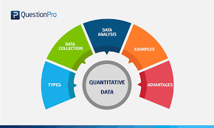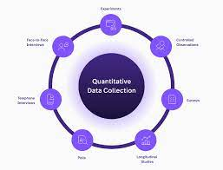

Quantitative data is the value of data in the form of counts or numbers where each data set has a unique numerical value. This data is any quantifiable information that researchers can use for mathematical calculations and statistical analysis to make real-life decisions based on these mathematical derivations.

Quantitative data answer questions such as “How many?”, “How often?”, “How much?”. This data can be verified and conveniently evaluated using mathematical techniques.

How to use quantitative data?

Quantitative data are used when a researcher is trying to quantify a problem, or address the "what" or "how many" aspects of a research question. It is data that can either be counted or compared on a numeric scale. For example, it could be the number of first year students at Macalester, or the ratings on a scale of 1-4 of the quality of food served at Cafe Mac. This data are usually gathered using instruments, such as a questionnaire which includes a ratings scale or a thermometer to collect weather data. Statistical analysis software, such as SPSS, is often used to analyze quantitative data.

Source :

<https://www.g2.com/articles/qualitative-vs-quantitative-data>

<https://libguides.macalester.edu/c.php?g=527786&p=3608639>

1. **What is qualitative data and how can you use it.**

Answer :

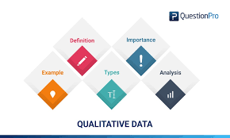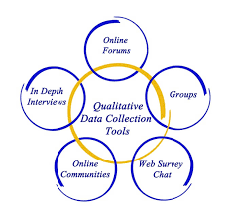

Qualitative data is non-statistical and is typically unstructured or semi-structured. This data isn’t necessarily measured using hard numbers used to develop graphs and charts. Instead, it is categorized based on properties, attributes, labels, and other identifiers.

Qualitative data can be used to ask the question “why.” It is investigative and is often open-ended until further research is conducted. Generating this data from qualitative research is used for theorizations, interpretations, developing hypotheses, and initial understandings.

How to use Qualitative data?

Qualitative data describes qualities or characteristics. It is collected using questionnaires, interviews, or observation, and frequently appears in narrative form. For example, it could be notes taken during a focus group on the quality of the food at Cafe Mac, or responses from an open-ended questionnaire. Qualitative data may be difficult to precisely measure and analyze. The data may be in the form of descriptive words that can be examined for patterns or meaning, sometimes through the use of coding. Coding allows the researcher to categorize qualitative data to identify themes that correspond with the research questions and to perform quantitative analysis.

Source :

<https://www.g2.com/articles/qualitative-vs-quantitative-data>

<https://libguides.macalester.edu/c.php?g=527786&p=3608639>

1. **Give an example of how quantitative and qualitative data can be used in conjunction with each other**

Answer :

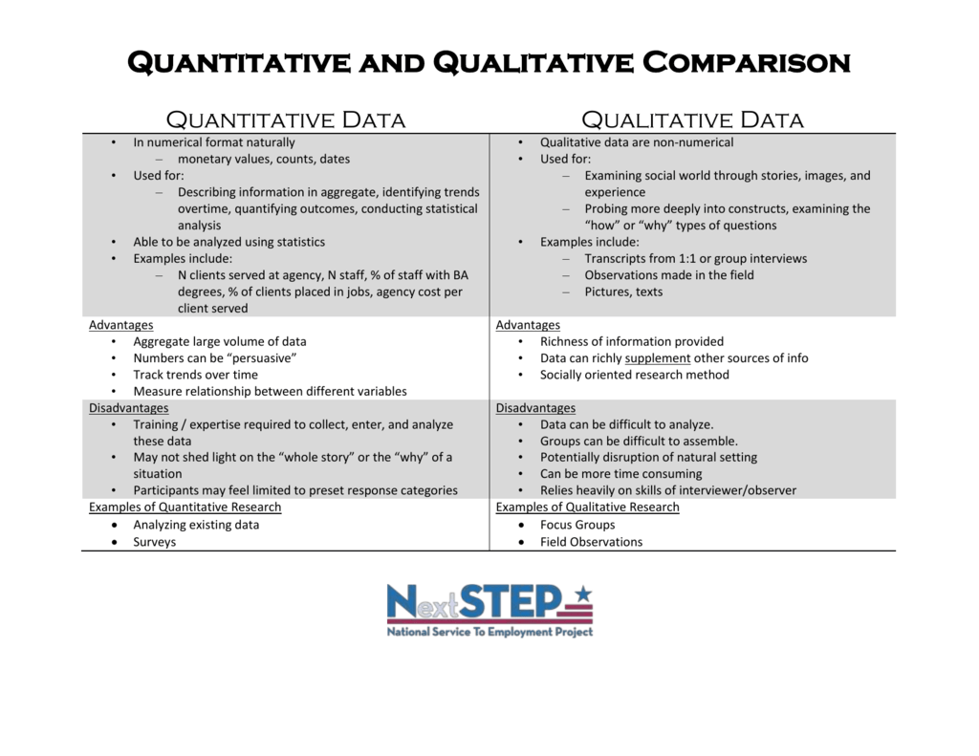

Using a combination of qualitative and quantitative data can improve an evaluation by ensuring that the limitations of one type of data are balanced by the strengths of another. This will ensure that understanding is improved by integrating different ways of knowing.

*Quantitative data provides you the what, but qualitative data provides you the why.*

here’s the example how both data can be used

***Example 1: Google Analytics + User Interviews***

Google Analytics offers a wealth of quantitative data, such as how many people visited your site, how they got there, and how long they stayed. The information is incredibly helpful and extremely detailed, but without thoughtful interpretation, it’s useless.

In many cases, Google Analytics’ quantitative data will help you pinpoint exactly where your problem lies. But only qualitative data can identify the cause of the issue. Why is that text box causing people to leave your site? Is the field too difficult to fill out? You’ll obtain this information through interviews, co-browsing sessions or feedback tools.

***Example 2: Social Media Stats + Community Engagement***

The value of social media is often difficult to quantify. Online retailers can use direct link tracking, but for service providers, tracking sales from social media is not so cut and dry.

Social media insight tools that measure clicks, engagement rates, and the number of followers reveal important statistics about your community. To discover which types of posts resonate most with your audience, you’ll need to do some qualitative investigation, such as reading and studying comments, analyzing sentiment, and making observations over time.

***Example 3: Marketing Events + Surveys***

The success of marketing events is often judged by hard data such as the number of attendees or sales made during the event. But qualitative research is great for putting a face to a number. By encouraging attendees to fill out a survey, you collect valuable information about attendees, such as demographic info, product feedback and detailed impressions of the event.

Source:

<https://voccii.com/qualitative-and-quantitative-data>

<https://www.questback.com/blog/5-reasons-to-combine-qualitative-and-quantitative-research/>

1. **What sort of methods could you use to determine client requirements for a website design and key information sources?**

Answer :

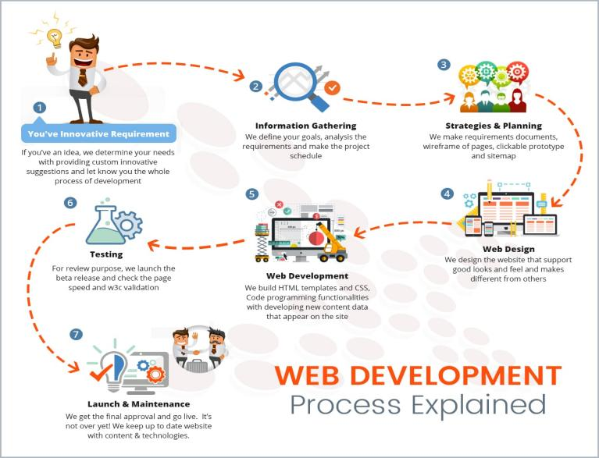

**Website Requirements**

Website requirements are a list of necessary functions, capabilities, or characteristics related to your website and the plans for creating it. There are several types of requirements that may be defined during the process that come together to focus and prioritize the project plan.

**Types of Requirements**

There are many different types of requirements documentation. At a higher level, most can fall within one of the following categories:

* **Business Requirements** define the objectives and what problems the stakeholder intends to solve with the product.
* **User Requirements** describe how user expectations and how they will interact with the product. Use the features, functions, and content described in your scenarios to develop your requirements. Your user scenarios should outline the tasks your users want to complete on your site.
* **Functional Requirements** provide details of how a product should behave and specify what is needed for development.
* **Quality-of-Service Requirements** detail what characteristics a product must maintain in order to maintain its effectiveness and any constraints.
* **Implementation Requirements** are used to detail changes in process, team roles, migration from one system to another, etc.

Source:

<https://www.usability.gov/how-to-and-tools/methods/requirements.html>

1. **Give some examples of client requirements for a website design**

Answer

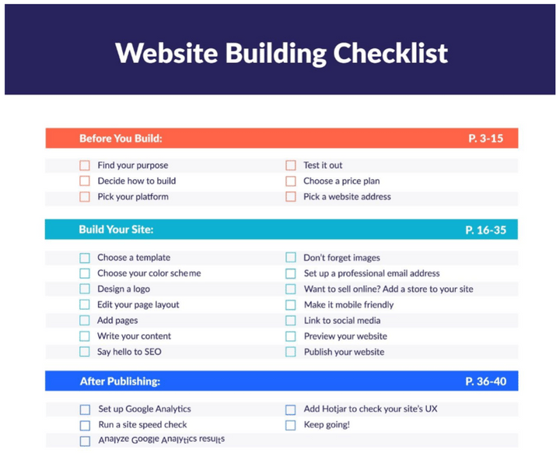

**1. Mobile Responsive Design**

A website is responsive when its layout adapts to the size of the viewers screen. It needs to be able to display well across a mobile device, a tablet, a laptop and a desktop.

**2.** **SSL Certificate**

An SSL or Secure Sockets Layer certificate applied to your website authenticates its identify and enables an encrypted connection between a web server and a web browser. It will ensure that all web traffic between your web server and the users browser is secure and cannot be read. It is protecting things such as login data, any information entered on a form and transactions. A few years back, Google confirmed that websites that have an SSL certificate and use the HTTPS protocol are given a better ranking in search, yet another great reason to ensure you apply an SSL certificate to your site.

**3. Website Hosting Service**

A website hosting service allows you to securely store the files that make up your website (images, HTML files etc) and to enable you to run your site live on the internet.

Before selecting your website hosting service, you need to understand the specific type of hosting you after, how much storage you will need and if they include an SSL certificate in their fee.

A great website hosting service will excel at speed, security and reliability.

**4. Redirects**

Redirects are required if you have an existing website and you will updating that website. Where you have original pages or content that may not be carried forward to the new site or the URL may be different than the original, you will want to set up redirects.

**5. Create and submit XML Sitemap**

An XML Sitemap is a roadmap of your website that leads search engines to all your important pages. It assists search engines to index your site and find information more quickly, increasing the chances of your website being found by Google and other search engines.

**6. Browser Capability**

A browser is a software application that enables you to access the World Wide Web such as Google Chrome, Safari or Firefox.

When you create a new website, you must check that your site displays and functions appropriately across the various browsers.

**7. Website Page Load Time**

Page load time is the time it takes for any page on your website to load in a browser. Slow site speed may result in poor search engine rankings, a negative user experience and lower overall site traffic.

To speed up your website page load time you want to ensure your images are as small as possible, minimise video content uploaded to your site (instead insert a link and ‘embed’ the video), your hosting service is optimised meaning little or no network latency.

Source

<https://whatmattersmarketing.com/website-technical-requirements-checklist/>

# Task 6: Multiple Choice Questions

1. Generally, how many points should a rating scale have?
   1. Five
   2. Four
   3. Ten
   4. Somewhere from 4 to 11 points

Reason:

The Likert scale is the most frequently used rating scale. Participants are provided with a scale and asked to select the most appropriate rating. Providing five to nine levels in the Likert scale is recommended. You may wish to provide anchors for every number, or anchor only the end points. You should also consider whether or not to allow a middle-position for users to settle on a neutral point. Some usability professionals prefer to remove the neutral point since they believe that people tend to gravitate towards neutral positions and they want to force respondents to come down on one side of the fence or the other. Be aware that if a participant truly does not have a preference one way or the other, forcing him/her to make a choice will introduce error into your results.  
Source :

<https://www.sciencedirect.com/topics/computer-science/rating-scale>

1. What is the problem(s) with this set of response categories to the question “What is your current age?” o 1-5 o 5-10 o 10-20 o 20-30 o 30-40
   1. The categories are not mutually exclusive
   2. The categories are not exhaustive
   3. Both a and b are problems
   4. There is no problem with the above set of response categories

1. You should mix methods in a way that provides complementary strengths and no overlapping weaknesses. This is known as the fundamental principle of mixed research.

a) True

b) False   
Reason:  
According to the fundamental principle of mixed research, the researcher should use a mixture or combination of methods that has complementary strengths and nonoverlapping weaknesses. This principle is important because it provides the researcher with a logic for mixing quantitative and qualitative research approaches.  
Source:

<https://www.sagepub.com/sites/default/files/upm-binaries/31987_Punch_Final_Proof.pdf>

1. According to the text, questionnaires can address events and characteristics taking place when?
   1. In the past (retrospective questions)
   2. In the present (current time questions)
   3. In the future (prospective questions)
   4. All of the above

Reason:

All of the option a, b and c are correct since every questionnaires could be used in many ways   
source: learner’s guide

1. Which of the following are principles of questionnaire construction?
   1. Consider using multiple methods when measuring abstract constructs
   2. Use multiple items to measure abstract constructs
   3. Avoid double-barrelled questions
   4. All of the above
   5. Only b and c

Reason:

Option b and c are the five basic of the principle of questionaire construction.

For option a, if we using multiple methods, the output will lead to another whole meaning.

Source:

https://norstatgroup.com/blog/five-basic-principles-for-writing-good-questionnaires

1. Which of these is not a method of data collection?
   1. Questionnaires
   2. Interviews
   3. Experiments
   4. Observations

Reason:

Experiment is not a method of data collection. Experiment is a procedure which can be repeated for indefinite times. It is also known as trial.

Source:

<https://www.toppr.com/ask/en-au/question/which-of-these-is-not-a-method-of-data-collection/>

1. Secondary/existing data may include which of the following?
   1. Official documents
   2. Personal documents
   3. Archived research data
   4. All of the above

Reason:

Data collected by someone else for some other purpose but being utilized by the investigator for another purpose is called secondary data. They are collected from published data by the state or central government, articles by local bodies, census data, magazines, periodicals, journals, publications by CSO, etc.

Source:

<https://www.toppr.com/ask/question/secondary-data-may-include-which-of-the-following/>

1. An item that directs participants to different follow-up questions depending on their response is called a ____________.
   1. Response set
   2. Probe
   3. Semantic differential
   4. Contingency question

Reason :

Contingency question – A question that is answered only if the respondent gives a particular response to a previous question. This avoids asking questions of people that do not apply to them (for example, asking men if they have ever been pregnant).

Source:

<https://home.csulb.edu/~msaintg/ppa696/696qstin.htm>

1. Which of the following terms best describes data that were originally collected at an earlier time by a different person for a different purpose?

a) Primary data

* 1. Secondary data
  2. Experimental data
  3. Field notes

Reason :

We should always remember that Secondary data is the term which describes data that we originally collected at an earlier time by a different person for a different purpose. The data is second-hand information since secondary data is not gathered by the user

Source :

<https://www.vedantu.com/question-answer/which-of-the-terms-best-describes-data-that-we-class-8-maths-cbse-60adcc87576d88681ac75984>

1. Researchers use both open-ended and closed-ended questions to collect data. Which of the following statements is true?
   1. Open-ended questions directly provide quantitative data based on the researcher’s predetermined response categories
   2. Closed-ended questions provide quantitative data in the participant’s own words
   3. Open-ended questions provide qualitative data in the participant’s own words
   4. Closed-ended questions directly provide qualitative data in the participants’ own words

Reason :

Open-ended questions are questions that do not provide participants with a predetermined set of answer choices, instead allowing the participants to provide responses in their own words. Open-ended questions are often used in qualitative research methods and exploratory studies. Qualitative studies that utilize open-ended questions allow researchers to take a holistic and comprehensive look at the issues being studied because open-ended responses permit respondents to provide more options and opinions, giving the data more diversity than would be possible with a closed-question or forced-choice survey measure. This entry expands on the many benefits of open-ended survey questions before examining the steps to writing well-constructed open-ended questions.

Source:

<https://methods.sagepub.com/reference/the-sage-encyclopedia-of-communication-research-methods/i14345.xml>

1. Open-ended questions provide primarily ______ data.
   1. Confirmatory data
   2. Qualitative data
   3. Predictive data
   4. None of the above

Reason

Open-ended questions are an integral part of Qualitative Market Research. This research technique depends heavily on open and subjective questions and answers on a given topic of discussion with room for further probing by the researcher, based on the answer given by the respondent. In a typical scenario, closed-ended questions are used to gather qualitative data from respondents.

Source:

<https://www.questionpro.com/blog/what-are-open-ended-questions/>

1. Which of the following is true concerning observation?
   1. It takes less time than self-report approaches
   2. It costs less money than self-report approaches
   3. It is often not possible to determine exactly why the people behave as they do
   4. All of the above

Reason :

Observation is way of gathering data by watching behavior, events, or noting physical characteristics in their natural setting. Observations can be overt(everyone knows they are being observed) or covert (no one knows they are being observed and the observer is concealed). The benefit of covert observation is that people are more likely to behave naturally if they do not know they are being observed. However, you will typically need to conduct overt observations because of ethical problems related to concealing your observation

Source

<https://www.cdc.gov/healthyyouth/evaluation/pdf/brief16.pdf>

1. Qualitative observation is usually done for exploratory purposes; it is also called ___________ observation.
   1. Structured
   2. Naturalistic
   3. Complete
   4. Probed

Reason :

Qualitative observation enables the researcher to observe, interact and gain a rich picture of participants in their natural environment. This data collection method allows you to better understand the processes, culture, or people under study. Qualitative observations are usually used by social scientists, sociologists, and psychologists to gain a more comprehensive understanding of human and animal behavior.

Source: <https://delvetool.com/blog/qualobservation>

1. When constructing a questionnaire, it is important to do each of the following except ______.
   1. Use "leading" or "loaded" questions
   2. Use natural language
   3. Understand your research participants
   4. Pilot your test questionnaire

Reason:

Leading questions are intentionally or unintentionally framed queries that prompt a respondent to answer in a particular way. So, while these types of questions may result in respondents answering in the way the survey creator had hoped, it results in survey bias which impacts the validity of the survey

Source:

<https://www.surveylegend.com/survey-questions/leading-questions/#:~:text=Leading%20vs%20Loaded%20Questions,they%20may%20not%20agree%20with.>

1. Another name for a Likert Scale is a(n):
   1. Interview protocol
   2. Event sampling
   3. Summated rating scale
   4. Ranking

Reason:

Since after the questionnaire is completed, each item may be analyzed separately or in some cases item responses may be summed to create a score for a group of items. Hence, Likert scales are often called summative scales.

Source:

<https://en.wikipedia.org/wiki/Likert_scale#:~:text=Hence%2C%20Likert%20scales%20are%20often%20called%20summative%20scales.>

1. Which of the following is not one of the six major methods of data collection that are used by educational researchers?
   1. Observation
   2. Interviews
   3. Questionnaires
   4. Checklists

Reason :

These are 6 major methods of data collection used by educational researchers

* + 1. Interviews
    2. Questionnaires and surveys
    3. Observations
    4. Documents and records
    5. Focus groups
    6. Oral histories

Therefore option D is not one of them.

Source : <https://www.jotform.com/data-collection-methods/>

1. The type of interview in which the specific topics are decided in advance but the sequence and wording can be modified during the interview is called:

a) The interview guide approach

* 1. The informal conversational interview
  2. A closed quantitative interview
  3. The standardized open-ended interview

Reason :

the guide approach is intended to ensure that the same general areas of information are collected from each interviewee; this provides more focus than the conversational approach, but still allows a degree of freedom and adaptability in getting information from the interviewee.

Source:

<https://managementhelp.org/businessresearch/interviews.htm>

1. Which one of the following in not a major method of data collection?
   1. Questionnaires
   2. Interviews
   3. Secondary data
   4. Focus groups
   5. All of the above are methods of data collection

Reason :

Since most of the major methods data collection based by quantity, therefore option b which focused on quality, are not in a major method of data collection

Source : <https://www.jotform.com/data-collection-methods/>

1. A question during an interview such as “Why do you feel that way?” is known as

a) Probe

* 1. Filter question
  2. Response
  3. Pilot

Reason:

Probing is asking follow-up questions when we do not fully understand a response, when answers are vague or ambiguous or when we want to obtain more specific or in-depth information

Source:

<https://fyi.extension.wisc.edu/programdevelopment/files/2016/04/Tipsheet34.pdf>

1. A census taker often collects data through which of the following?
   1. Standardized tests
   2. Interviews
   3. Secondary data
   4. Observations

Reason :

A census is a survey conducted on the full set of observation objects belonging to a given population or universe.

Source : <https://ec.europa.eu/eurostat/statistics-explained/index.php?title=Glossary:Census>

1. The researcher has secretly placed him or herself (as a member) in the group that is being studied. This researcher may be which of the following?

a) A complete participant

* 1. An observer-as-participant
  2. A participant-as-observer
  3. None of the above

Reason:

In this complete participant, the observer is fully engaged with participants. So, in the soccer study, the observer might join the team (assuming he/she has the necessary qualifications) and be involved in the team activities on and off the field

Source : <https://researchdesignreview.com/2017/10/19/the-five-observer-roles-in-ethnography/>

1. Which of the following is not a major method of data collection?
   1. Questionnaires
   2. Focus groups
   3. Correlational method
   4. Secondary data

Reason : same as question number 18, it’s not include in major method data collection since correlational methods are a form of research that include “quasi-experimental” designs such as survey research or naturalistic observations, in which different groups are compared, but cause and effect between variables cannot be determine.

Source: <https://www.alleydog.com/glossary/definition.php?term=Correlational+Methods#:~:text=Correlational%20Methods%20are%20a%20form,between%20variables%20cannot%20be%20determined.>

1. Which type of interview allows the questions to emerge from the immediate context or course of things?

a) Interview guide approach

* 1. Informal conversational interview
  2. Closed quantitative interview
  3. Standardized open-ended interview

Reason:

An Informational Interview (also known as an informational meeting, coffee chat, or more generically, networking) is a conversation in which a person seeks insights on a career path, an industry, a company and/or general career advice from someone with experience and knowledge in the areas of interest. Informational interviews are often casual and candid conversations where both parties are focused simply on acquiring and sharing knowledge

Source :

<https://en.wikipedia.org/wiki/Informational_interview>

1. When conducting an interview, asking "Anything else? What do you mean? Why do you feel that way?," etc, are all forms of:
   1. Contingency questions
   2. Probes
   3. Protocols
   4. Response categories

Answer:

Similar to question 19.

Probing is asking follow-up questions when we do not fully understand a response, when answers are vague or ambiguous or when we want to obtain more specific or in-depth information

Source:

<https://fyi.extension.wisc.edu/programdevelopment/files/2016/04/Tipsheet34.pdf>

1. When constructing a questionnaire, there are 15 principles to which you should adhere. Which of the following is not one of those principles?
   1. Do not use "leading" or "loaded" questions
   2. Avoid double-barrelled questions
   3. Avoid double negatives
   4. Avoid using multiple items to measure a single construct

Answer :

Option D are wrong, since multiple items are only used to measure abstract construct.

Source :

<https://www.sagepub.com/sites/default/files/upm-binaries/26101_7.pdf>

1. A customer-based Service Level Agreement structure includes:
   1. An SLA covering all Customer groups and all the services they use
   2. SLAs for each service that are Customer-focused and written in business language
   3. An SLA for each service type, covering all those Customer groups that use that Service
   4. An SLA with each individual Customer group, covering all of the services they use

Answer :

A Service Level Agreement (or SLA) is the part of a contract which defines exactly what services a service provider will provide and the required level or standard for those services. The SLA is generally part of an outsourcing or managed services agreement, or can be used in facilities management agreements and other agreements for the provision of services

Source:

<https://www.keystonelaw.com/keynotes/service-level-agreements>

1. Which of the following best describes the goal of Service Level Management?
   1. To maintain and improve IT service quality in line with business requirements
   2. To provide IT services at the lowest possible cost by agreeing with Customers their minimum requirements for service availability and ensuring performance does not exceed these targets
   3. To provide the highest possible level of service to Customers and continuously improve on this through ensuring all services operate at maximum availability
   4. To ensure that IT delivers the same standard of service at the least cost

Answer :

Service Level Management (SLM) aims to negotiate Service Level Agreements with the customers and to design services in accordance with the agreed service level targets. This ITIL process is also responsible for ensuring that all Operational Level Agreements and Underpinning Contracts are appropriate, and to monitor and report on service levels.

Source:

<https://wiki.en.it-processmaps.com/index.php/Service_Level_Management>

1. The process to implement SLAs comprises of the following activities in sequence:
   1. Draft SLAs, catalogue services, review underpinning contracts and OLAs, draft SLRs, negotiate, agree

SLAs

* 1. Draft SLAs, review underpinning contracts and OLAs, negotiate, catalogue services,
  2. Review underpinning contracts and OLAs, draft SLAs, catalogue services, negotiate, agree SLAs
  3. Catalogue services, establish SLRs, review underpinning contracts and OLAs, negotiate service levels, agree SLAs

Answer :

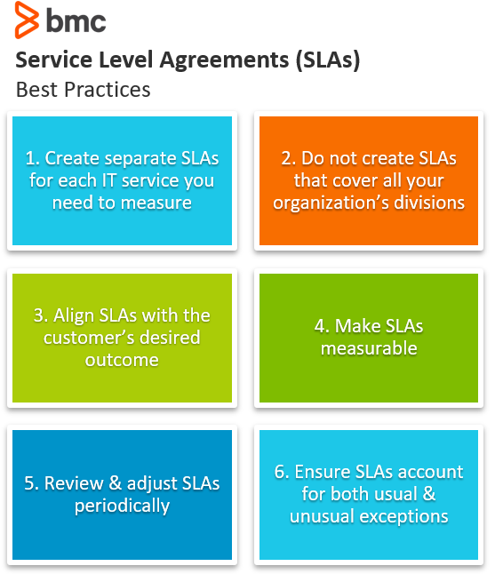

An IT SLA—or IT service-level agreement—is a contract between IT support and an end user within the same organization. Typically, IT SLAs establish a clear understanding of service parameters by defining the services extended, the quality standards that must be adhered to, and the timelines within which the services must be delivered. Operational-level agreements (OLAs) and underpinning contracts (UCs) are agreements that IT support makes with internal departments and with vendors or partners, respectively. The OLAs and UCs act as constituents of the final SLA that the IT support team draws up with end users.

Source

<https://blogs.manageengine.com/help-desk/servicedesk/2014/12/10/5-steps-to-successfully-implement-an-it-sla.html>

1. Which of the following is an example of a service level agreement (SLA) between an information systems support unit and a research unit in the laboratories of a large company?
   1. The maximum response time to get the system operational should it fail.
   2. The minimum ‘up-time’.
   3. The types of information that will be provided as standard.
   4. All of the above.

Answer:

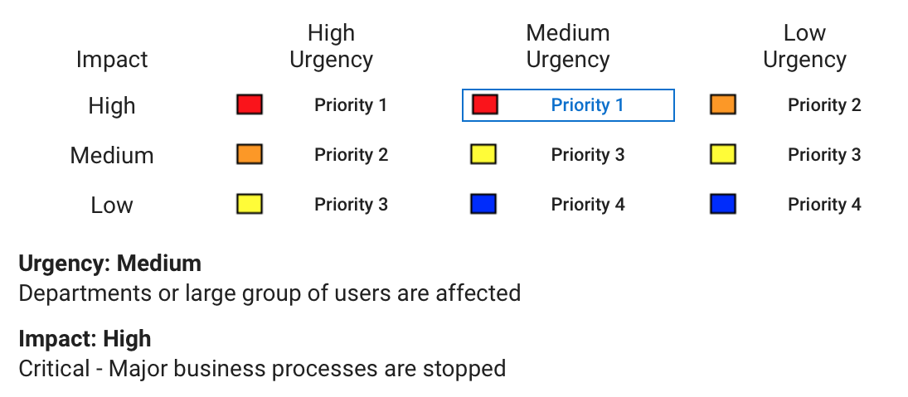

Most maintenance agreements have an SLA or Service Level Agreement component. SLAs establish customer expectations with regard to the service provider’s performance and quality in a number of ways. In the case of service agreements, SLAs usually revolve around response times and how long it will take a service provider to respond when you raise an issue. Issues have to be raised in a specific way – for example an online system or via a help desk.

Source:

https://calibreone.com.au/service-level-agreements/

1. Some organisations bring a degree of formality to the internal customer concept by encouraging (or requiring) different parts of the operation to agree on:

a) Internal service agreements

* 1. Service level agreements
  2. Formal provision agreements
  3. Delivery agreements

Answer :

A service-level agreement (SLA) defines the level of service expected by a customer from a supplier, laying out the metrics by which that service is measured, and the remedies or penalties, if any, should the agreed-on service levels not be achieved. Usually, SLAs are between companies and external suppliers, but they may also be between two departments within a company.

Source :

<https://www.cio.com/article/274740/outsourcing-sla-definitions-and-solutions.html>

# Search Index

A

alphanumeric 9

C

catalogue 2

census 18

E

eftpos 2

I

interview 11

informal 22

L

Linux server 2

M

Marketing events 12

Marketing manager 2

O

observation 11

Oral histories 22

Q

Questionnaire 11

Quantitative data 10

Qualitative data 10

S

server 2

survey 12